** Madawaska Valley**

**Association For Community Living**



ANNUAL REPORT 2022 – 2023

April 1, 2022 to March 31, 2023

**MISSION**

Working together to improve the quality of life for people with intellectual disabilities.

**VISION**

We seek a community without barriers, where people can achieve personal success and fulfill their dreams. We envision Madawaska Valley Association for Community Living as a leader in providing service and supports that promote inclusion for all.

**MVACL BOARD OF DIRECTORS 2022 – 2023**

We would like to take this opportunity to thank our committed Board of Directors for their continued guidance and support of the work of MVACL.

**Executive** **Directors**

Bridget Gutoskie, **President**  Joanne Hartwig

Corrine Higgins, **Vice President** Edna Yutronkie

Lavina Prince, **Honorary Vice President** Rosemary Miller

Jane Visneskie **- Treasurer**

A Message to our Stakeholders

Dear Friends of MVACL

This annual report focuses on the period from April 1st, 2022- March 31st, 2023. In April we were still in the midst of Covid but everyone was hopeful that with spring and summer would come fewer restrictions.

The first great news of the year came when the government announced on April 22, that the temporary $3/hr. wage enhancement was being made permanent. This much deserved increase brought further hope that it would improve our dire recruitment and retention. Over the course of the year, we had 16 new hires, and 11 people left the agency.

Community Living Month in May of 2022 was memorable because it was the first-time people we support and staff gathered together, although outside, since March of 2020. Our kickoff BBQ was extremely well attended and set the tone for many other events throughout May. People were happy to be outside on that cool but sunny day!

Two of our DSPs successfully completed their DSW this year. Congratulations Megan Bush and Trevor Zilney!

Our collective agreement expired March 31, 2021, yet it wasn’t until June 15th & 16th of 2022, that our parties were able to get back to the table to begin negotiations. By March 2023 we had yet to come to an agreement. Contributing to labour relations issues was the skyrocketing cost of living, that affects not only our staff, but also the people we support and our agency.

Despite continued challenges support staff worked diligently to help people they support to get back out in the community and resume some semblance of normalcy in their lives. People were able to get out hiking, biking, gardening and generally enjoying the out of doors (as evidenced by the beautiful photos on our cover).

In August we were happy to be able to welcome a new resident to our Group Living program. Late March we welcomed a second! Things were looking up!

In September, during our annual review we were found to be in compliance. More great work by our teams.

Our last Strategic Plan covered from 2019 – 2021. Although we met many of our goals, others remained incomplete, primarily due to the consequences of Covid. In November of 2022, with financial support from our Board of Directors, we began the task of creating a new plan facilitated by Lori Stanley Non-Profit Consulting. We had excellent participation and were grateful to supported people, families, board members, staff and community partners who contributed through surveys and focus groups. The final plan was completed mid-February and was broadly distributed during Community Living Month in May 2023.

We continued to meet and work with community partners throughout the year. Another high point for some supported people was when MV Hospice donated Ipods to our agency. These devices were greatly appreciated and much enjoyed.

While covid has not been eradicated the level of focus it requires from us has certainly lifted. We are grateful for more opportunity to put focus where it belongs, on improving the quality of life for those we support.

Our journey continues! Many thanks to all who participate and help along the way.

Monica



**Dean has been enjoying**

**listening to an iPod he borrowed**

**from the Learning Centre!**

**Thank you to our community partners at**

**Madawaska Valley Hospice Palliative**

**Care for the generous donation of these**

**devices.**

In October of 2022, MVACL started the process to complete another Strategic Plan. Many discussions were had and we were excited to have a new plan in place in May of 2023. Pictured from left to right are the Strategic Planning Committee Members, Monica Prymack, Nicole Castle, Lea Walsh, Janice Henry, Lori Stanley (Strategic Plan Facilitator), Kelly Dombroski.

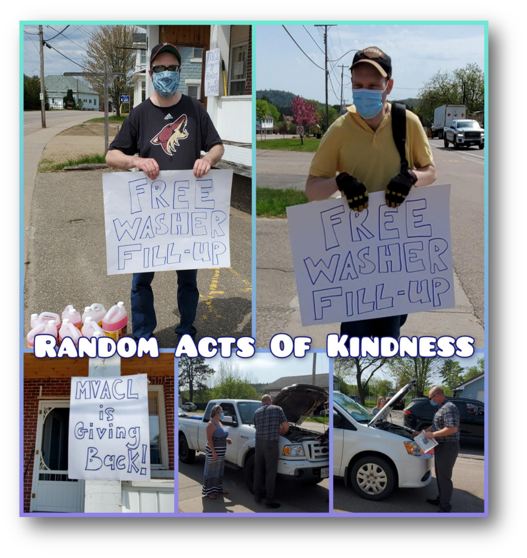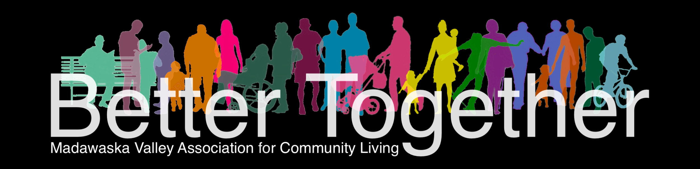

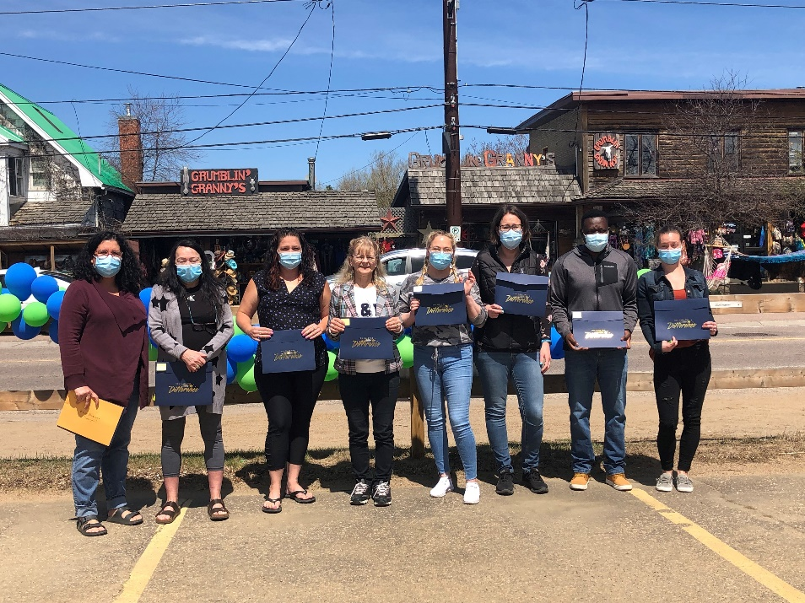

MVACL was happy to give back to the Community by offering a free windshield washer fill up day. The sun was shining as Rhys and Tom waved in the cars!!

As a kickoff to Community Living Month, we were so thrilled to recognize the following people with 15 years of service awards. Pictured left to right are Kelly Norlock, Karen Hawthorne, Melissa Gogolin, Janet Paplinskie, Laura Evans, Melissa Craftchick, Simon Fero and Meghan Bush. MVACL would like to congratulate you and thank you for all your hard work and years of dedication.