Madawaska Valley Association
For Community Living
Annual Report 2023 - 2024

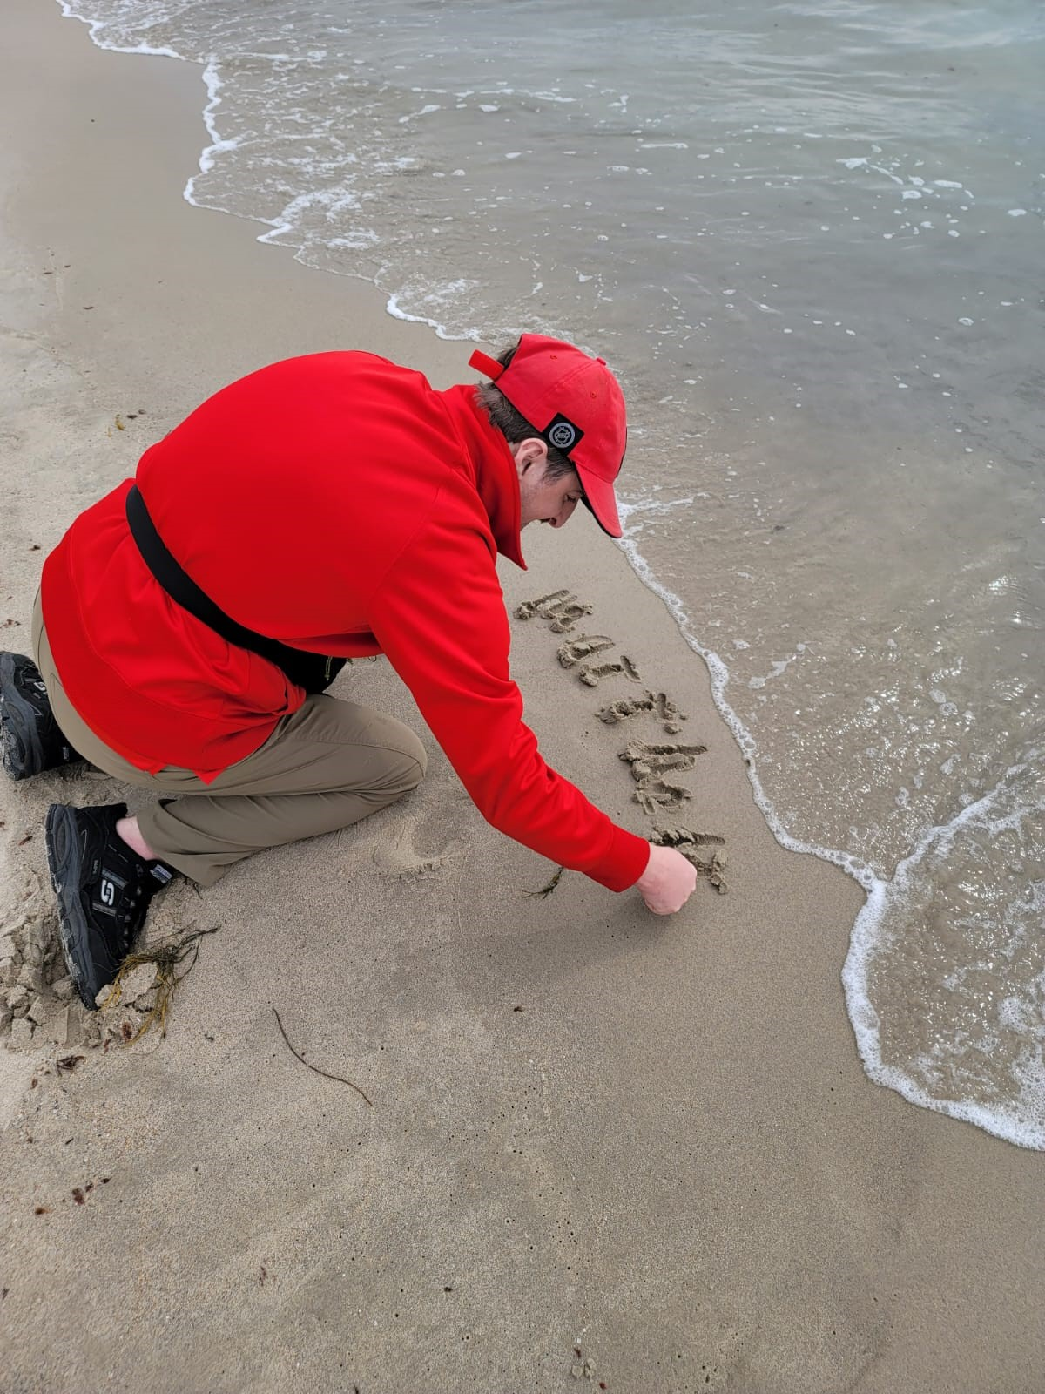

REALIZING THE DREAM OF SEEING THE OCEAN ON THE EAST COAST
MISSION

Working together to improve the quality of life for people with intellectual disabilities.

VISION

We seek a community without barriers, where people can achieve personal success and fulfill their dreams. We envision Madawaska Valley Association for Community Living as a leader in providing service and supports that promote inclusion for all.

MVACL BOARD OF DIRECTORS 2023 - 2024

We would like to take this opportunity to thank our committed Board of Directors for their continued guidance and support of the work of MVACL.

Executive Directors
Bridget Gutoskie, President Joanne Hartwig
Corrine Higgins, Vice President Edna Yutronkie
Jane Visneskie, Treasurer Rosemary Miller
Lavina Prince, Honorary Vice President

MVACL’S VALUES AND PRINCIPLES:

Everyone will…

- Provide supports and services that promote choice, personal success, inclusion, growth and development

- Promote an environment of respect, shared trust and cooperation

- Provide the highest quality of service provision

- Provide a safe and healthy environment

- Contribute ideas, knowledge and participates in continuing education

- Encourage and advocate for protection against unethical and/or illegal practices

- Promote inclusion and equitable treatment

- Serve as a responsible steward for public and private fund

A Message to our Stakeholders

Dear Friends of MVACL

Each year, as we meet for our AGM, we have the opportunity to reflect on the work of our agency over the past year.
The Ministry’s Journey to Belonging (J2B) initiative continues to be a work in progress. Introduced in 2021, this project is about the work that is necessary to make services for people with developmental disabilities better. Much work has been done over the years to include people with developmental disabilities in the community however there is still work to do. Being included in the community is about being respected and feeling welcomed.
The first goal on our Strategic Plan is to expand programs to support more people. Currently there are approximately 50 thousand people on the wait list for developmental services in Ontario. There are approximately 34 thousand people currently receiving services.
Over the past year MVACL has been working to find effective ways for us to administer Passport funds for people in receipt of this funding. Passport is a reimbursement program. People must first pay for a service and the Passport program reimburses them. The inability to pay up front has made it difficult and in many cases prohibitive, for people to utilize these funds. Our pilot project has been to provide this service to people already in our Group Living, Supported Independent Living, Community Participation and Respite programs. We hope to expand this to others in the greater community.
This fall, we have introduced new fee-for-service programming for anyone in our community who wishes to participate. So far these have been extremely well received, and we are working hard on finding ways to offer more programs in the future. This program is called Community Connect and runs primarily from what used to be the candy store.
In preparation for the Journey to Belonging, MVACL is working with Community Living Renfrew County South (CLRCS), Community Living Upper Ottawa Valley (CLUOV) and Rainmaker Solutions to explore our potential for finding efficiencies.

During 2023-2204, Community Living Ontario launched the #5tosurvive campaign. This initiative was widely supported by agencies across the province in an effort to get the government to provide a 5% increase to our base funding, as a starting point. In the past 30 years Developmental Service Agencies had received only a meager 3.9% increase to this funding, while the consumer price index has risen 60%. This effort resulted in mild success with the promise of a 3% increase to our base budget in 2024.
Community Living Ontario introduced a new campaign at the CLO conference in September, called #waitingtobelong. News on this to follow.
We are currently working with our Local OPSEU 473, on a new collective agreement. We are hopeful we can be successful working together.
Last Christmas we held a successful fundraising campaign over the Christmas holidays, which started an “Opportunities Fund” where people who cannot afford to participate in an activity or opportunity can apply for subsidy.
Our annual Baseball tournament was once again the highlight of Community Living Month in May. This year we hosted 7 teams from across the valley and a great time was had by all.
Recruitment remains a challenge, and we ask all our stakeholders to think of us when speaking with others about employment opportunities.
With gratitude to all of those who work for, and support the efforts of MVACL,

With thanks,

Monica
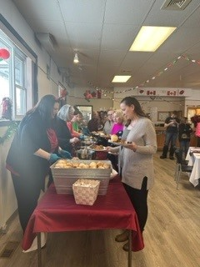
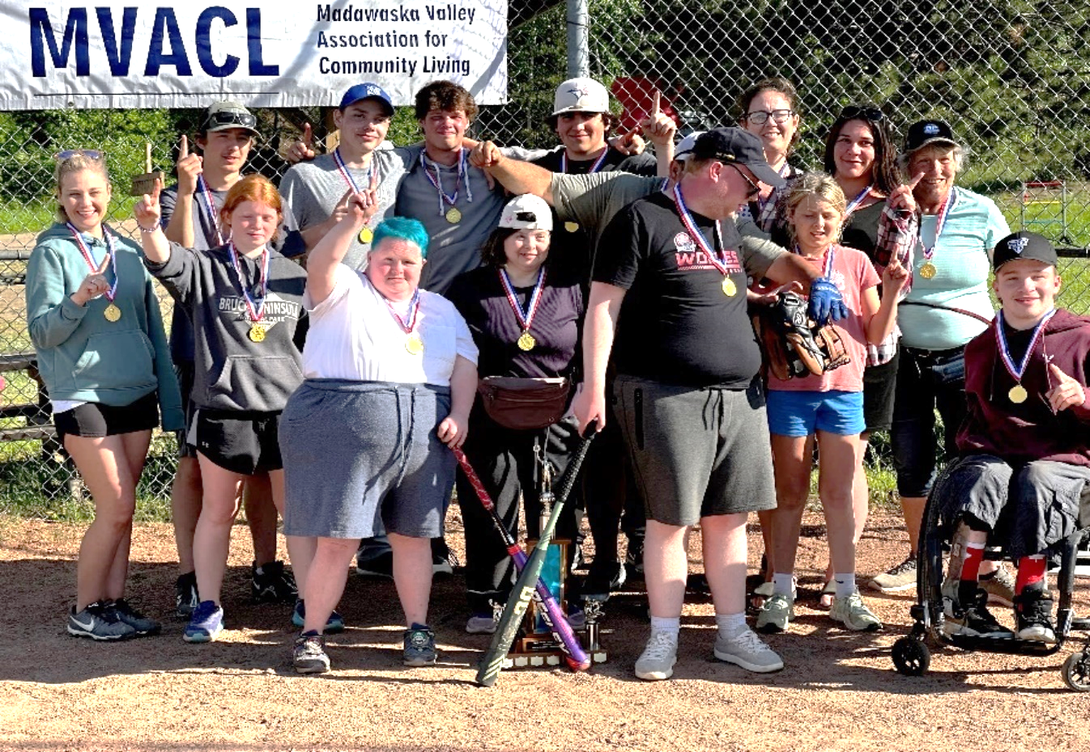
Our annual Baseball Game for Community Living Month was a much-anticipated event. The Swamp Donkey’s were the grand champions, while CLUOV came in a close second.
HIGHLIGHTS

The Christmas Dinner was well attended by staff and supported people. A wonderful meal was provided Andrea Budarick free of charge, with proceeds from her “Donuts for Charity” fund. Board members and the Admin team were happy to help out with serving the delicious meal.

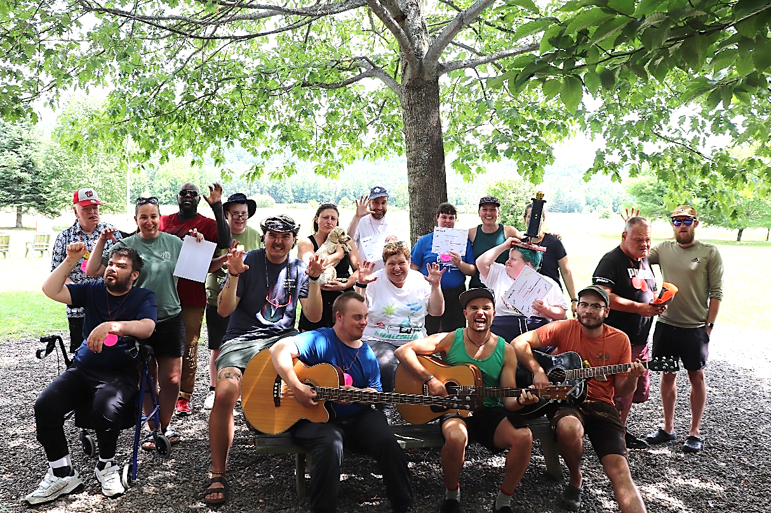
Boundless Summer Camp was a great opportunity for everyone to enjoy the outdoors. A special thanks to the Boundless team for providing us this opportunity to make memories at no charge. We hope to continue this partnership for years to come.

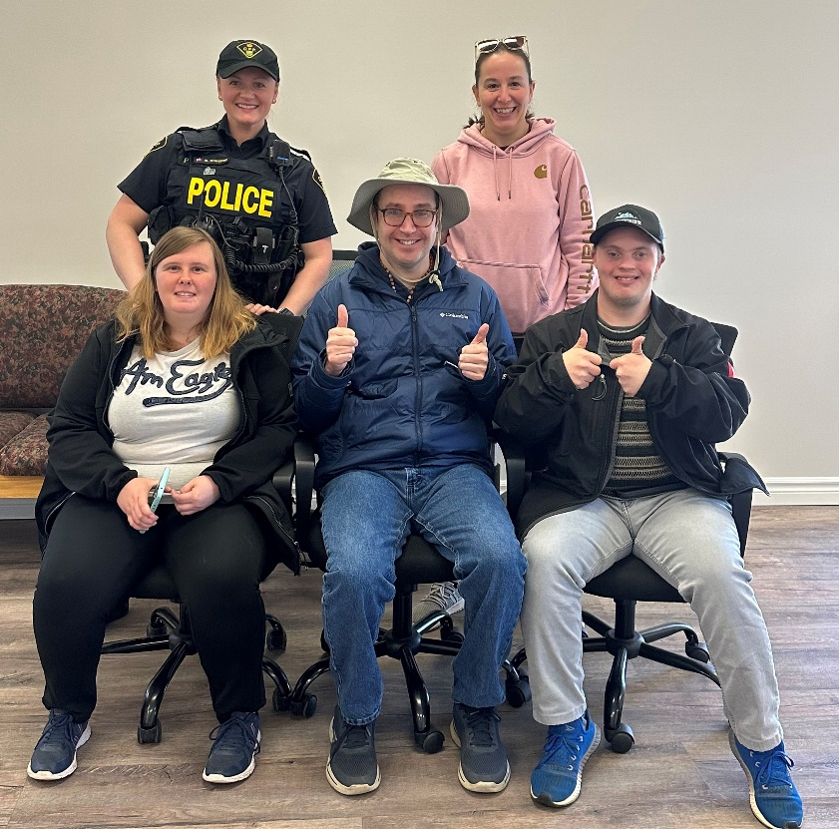
Opp Officer Brianna visited the Learning Centre to give an insightful presentation on internet safety. Many good tips were provided on how to be safe in the cyber world.

