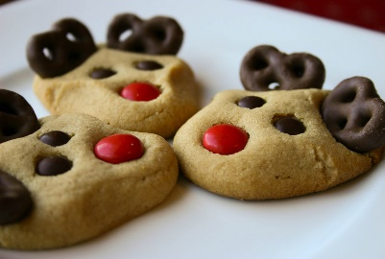

BAKED GOODS EXCHANGE EVERYONE WELCOME!

If you would like to sign up for our Baked Goods Exchange please do so by November 11, 2024, by giving your name and what you will be baking. On November 12, 2024, we will let you know how many dozens of cookies or squares (must be homemade) you will need to make. On November 26, 2024, your baked goods will need to be dropped off at Community Connect by 10:00am. On November 26, 2024, all your packaged exchanged baked goods will be ready for pick up between 2pm and 4pm.

Please contact Kelly Norlock

at 613-756-6644 or [knorlock@mvacl.ca](mailto:knorlock@mvacl.ca)

to sign up