**FEBRUARY CRAFT!**

**Wednesday February 26, 2025**

**10:00 till 2:00pm**

**Location: Community Connect**

**Cost: $25.00 for craft and lunch**

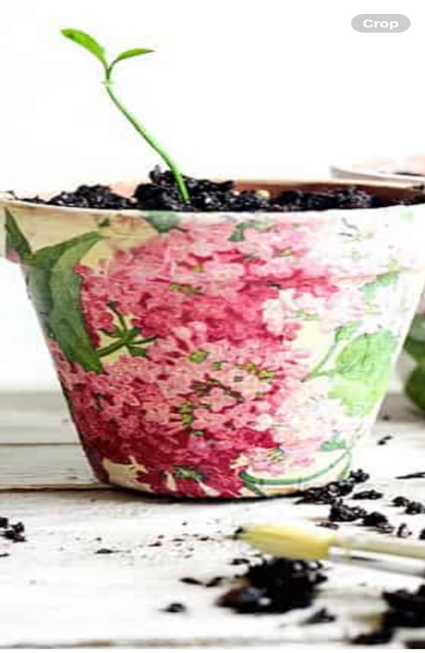

**Design a flowerpot and plant a plant in it!**

**Tomato Macaroni Soup, juice & mini cupcake**

**Please call or e-mail Kelly Norlock at 613-756-6644 or** [**knorlock@mvacl.ca**](mailto:knorlock@mvacl.ca) **to sign up by Friday February 21, 2025.**

**Space is limited**