Madawaska Valley Association

For Community Living

**ANNUAL REPORT 2021-2022**

**April 1, 2021- (month 13 of the Pandemic) to March 31, 2022 – (month 24 of the Pandemic)**

**MISSION**

Working together to improve the quality of life for people with intellectual disabilities.

**VISION**

We envision Madawaska Valley Association for Community Living as a leader in providing service and supports that promote inclusion for all. We seek a community without barriers, where people can achieve personal success and fulfill their dreams.

**MVACL BOARD OF DIRECTORS 2020-2021**

We would like to take this opportunity to thank our committed Board of Directors for their continued guidance and support of the work of MVACL.

**Executive** **Directors**

Bridget Gutoskie, **President**  Joanne Hartwig

Corrine Higgins, **Vice President** Edna Yutronkie

Jane Visneskie, **Treasurer** Rosemary Miller

Lavina Prince, **Honorary Vice President**

**Photo of the Board**

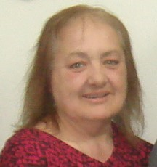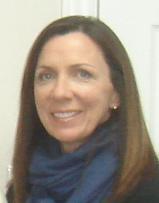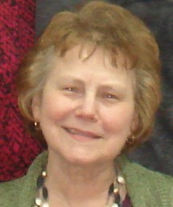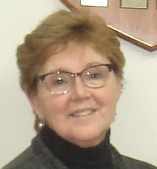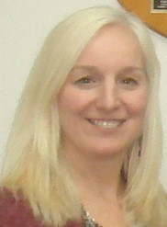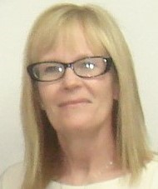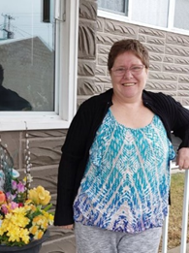

**A Message from our Board President**

Let me start with thanking this incredible group gathered here this afternoon. Your support of MVACL has been outstanding.

The agency has been so fortunate to have dedicated and caring staff. From Monica and her administration, to front line employees, every one gives their all plus to those that MVACL supports. Thank you for guiding us.

Corinne, Edna, Jane, Joanne, Lavina and Rosemary………. What can I say? You each bring unique talents and knowledge to the board group. We have teachers, business people, parents and self advocates. All of the group wear more than one hat. Everyone here is joined in the desire to see MVACL flourish. Thank you all for your unwavering support of MVACL and its mission statement.

While we were unable to proceed with the upgrades to the old candy store, I am sure that the right project is headed our way. We’ll know when we hear it.

Stay healthy, stay safe!

**Bridget**

Dear Friends of MVACL

It is my hope that the photo on this cover demonstrates that despite major challenges, celebrations and joy are alive and well.

In 2019 we worked with all of you to create a Strategic Plan that would take us through 2021. The Key themes were:

* Increase Training and Development Opportunities
* Increase Community Understanding of Inclusion through Awareness and Education
* Provide Creative Solutions to Increase and Improve Service Provision

Although we got off to a good start, in early ***March 2020 the Pandemic hit***, putting many of our goals on the back burner. For full details see the Video that provides further details of which objectives we met and which we didn’t.

Our first priority continues to be the safety, health and wellbeing of those we support and our staff.

I’d like to focus here on the many remarkable things that happened between ***April 1st 2021 and March 31st, 2022***.

It wasn’t until April 2021, into our second year of Covid, that the vaccine was available to all those we support and our staff. We had strong compliance with our effort to have the ***large majority of our MVACL community vaccinated***. All employees of MVACL worked incredibly hard throughout the year to keep those we support, themselves, and families safe. We were thrilled that it wasn’t until late fall 2021 that we had our first few cases of Covid. Very early in January 2022, the Health Unit had declared our first outbreak.

The people we support, their families and our staff team worked diligently to ensure the best outcomes for all. Although 6 supported people, and 25 staff tested positive during this period of time, none were gravely ill. We had weathered 21 months without an outbreak.

During this second year, people we support and their staff were very creative in their efforts to keep active and engaged. Staff and supported people helped to give back to the community by offering a free windshield washer fill up day as well as supplying our local grocery stores with coffee and doughnuts. We held a drive through BBQ for everyone. Supported people chose 5 local people who made a difference in their lives and presented them with gift certificates. Trips were taken to Algonquin Park, cottages were rented and slowly things started to open up allowing supported people to once again get out into the community.

By the end of March, we still had staff on Leave due to Covid and we had a few resignations. These were trying times for all. Fortunately the $3/hr. Temporary Wage Enhancement remained in place from Oct. through the end of March.

We brought our 2nd person into service during Covid, in February. We’re happy to say this young man is happy and is making new friends despite restrictions.

Plans to “repurpose” the old Candy store have remained on hold. The space has been used regularly throughout the pandemic as an alternate meeting space when it has been too cold to meet outside, or while visitors to our Admin. building were restricted. Work on our Killaloe location continues, and we look forward to our new partners sharing the space with us in April 2022.

We continue to grow interest in our organization through our Website, Facebook and Instagram pages. Currently we have 385 followers on Facebook, as well as 107 followers in Instagram. We provide updates as well through our Newsletter and calendars. Throughout 2021/22 we were active participants in the Madawaska Communities’ Circle of Health, Inclusion Renfrew County (our county DS planning table), the MCCH Ethics committee and the Barry’s Bay Rec Committee.

We are learning to live with Covid and the changes it has brought. In 2022 we will ask again for everyone’s help as we work to create a new Strategic Plan to set our course for the coming years.

With gratitude to all who are a part of this journey,

Monica