**MARCH CRAFT!**

**Wednesday March 19, 2025**

**10:00 till 2:00pm**

**Location: Community Connect**

**Cost: $25.00 for craft and lunch**

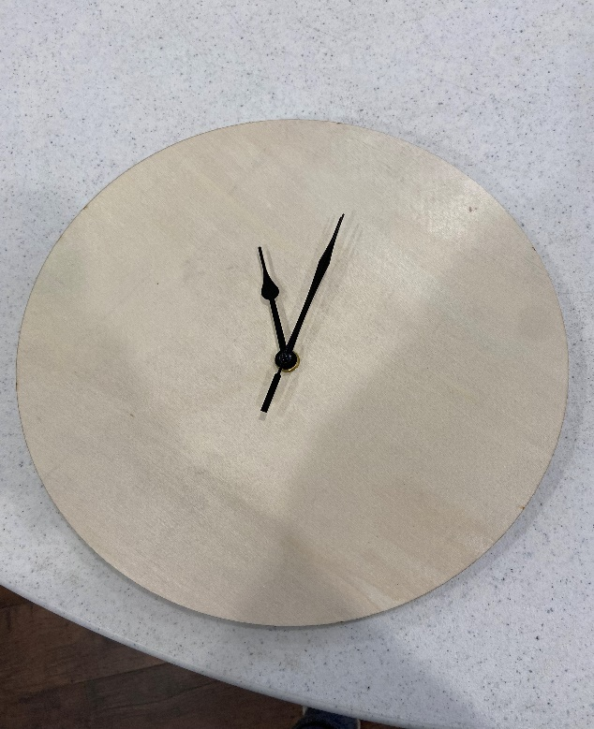



[This Photo](http://www.creationsbykara.com/2008/12/corn-chowder.html/) by Unknown Author is licensed under [CC BY-NC-ND](https://creativecommons.org/licenses/by-nc-nd/3.0/)

**Design your own CLOCK!**

**Creamy Potato & Bacon Soup, Juice & Cookie**

**Please call or e-mail Kelly Norlock at 613-756-6644 or** [**knorlock@mvacl.ca**](mailto:knorlock@mvacl.ca) **to sign up by Friday March 14, 2025.**

**Space is limited**