MARCH MOVIE NIGHT!

Thursday March 20, 2025

@ Community Connect 4-8 pm

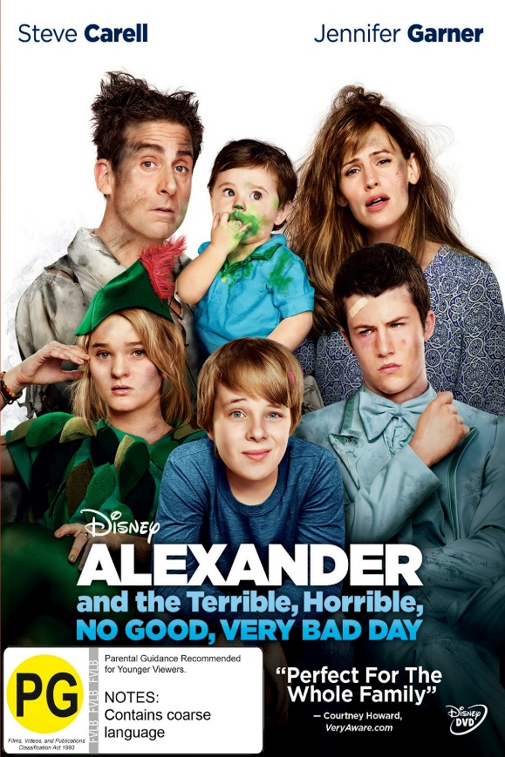

[This Photo](https://apkk02.blogspot.com/2015/04/alexander-and-terrible-horrible-no-good.html) by Unknown Author is licensed under [CC BY](https://creativecommons.org/licenses/by/3.0/)

$25 includes:

Dinner: Chicken Fingers & Smiley Fries & Juice

Popcorn or chips & pop while watching the movie.

Please call or e-mail Kelly Norlock

At 613-756-6644 or [knorlock@mvacl.ca](mailto:knorlock@mvacl.ca)

to sign up by Monday March 17, 2025.