THEMED MOVIE NIGHT!

Please wear holiday pajamas to be entered into a draw.

Thursday December 5, 2024

@ The Learning Centre 4-8 pm

Home Alone #2

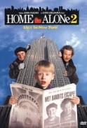

$20 includes:

Dinner: Chilli, bun and juice

Popcorn or chips & pop while watching the movie.

Please call or e-mail Kelly Norlock

At 613-756-6644 or [knorlock@mvacl.ca](mailto:knorlock@mvacl.ca)

to sign up by Wednesday Dec 4 at 12pm.