THEMED MOVIE NIGHT!

Please wear a holiday hat or headband to be entered into a draw.

Monday December 16, 2024

@ The Learning Centre 4-8 pm

The Grinch

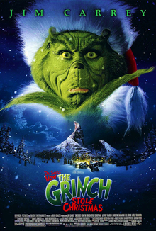

$20 includes:

Dinner: Chicken burger, Caesar salad and juice

Popcorn or chips & pop while watching the movie.

Please call or e-mail Kelly Norlock

At 613-756-6644 or [knorlock@mvacl.ca](mailto:knorlock@mvacl.ca)

to sign up by Friday December 13, 2024.