NEW YEARS EVE MOVIE MATINEE!

Tuesday December 31, 2024

@ Community Connect 11am-3pm

Inside Out 2

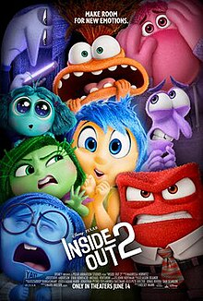

$20 includes:

Lunch: Personal Charcuterie Plate and Juice

Popcorn or Chips & Pop while watching the movie.

Please call or e-mail Kelly Norlock

At 613-756-6644 or [knorlock@mvacl.ca](mailto:knorlock@mvacl.ca)

to sign up by Friday December 23, 2024.