The Learning Centre is open for telephone and virtual meetings: Tues, Wed, Thurs and Fri from 930-330 by appointment.
Contact Heidi at 613 756 3817 x205

SUNDAY | MONDAY  May is Community Living Month.  Watch for Random Acts of Kindness popping up around your community.  Be courageous with your kindness. Do your part. Pay it forward. | TUESDAY | WEDNESDAY | THURSDAY | FRIDAY | SATURDAY
 |  |  |  |  |  | 1
2 | 3 | 4  Tech Tuesdays Contact Heidi 10-2 | 5  Radio Bingo | 6 | 7 | 8
9 | 10  3-4pm | 11  Tech Tuesdays Contact Heidi 10-2 | 12  Cate Collins  “Reconnect with the power house in you”  Webinar 10-1130 | 13  Winners of Random Acts of Kindness in the Community Delivery | 14 | 15
16 | 17  3-4pm | 18  Tech Tuesdays Contact Heidi 10-2 | 19  Radio Bingo | 20  Internet Safety Training | 21  Nominations for Job Well Done are Drawn for a Chance to Win Prizes | 22
23  30 | 24  Victoria day  31 | 25  Tech Tuesdays Contact Heidi 10-2 | 26 | 27  OFL Lunch and learn | 28  Community Living Month BBQ. 11-2 Details TBA | 29
ONLINE LEARNING
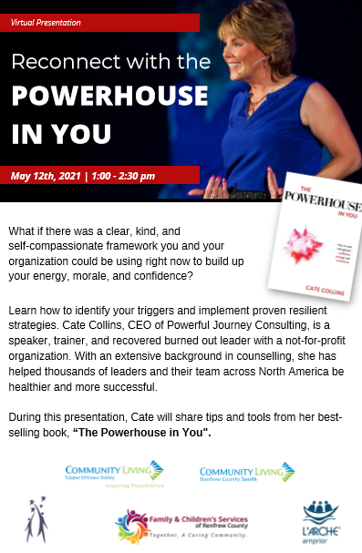
Call or email Heidi to sign up! Spaces are limited…
Open Furtures Learning Module of the Month (lunch and learn):
May 27th 11-12 Building Friendships and Community
In this module, leading expert Kay Mills frames her personal experiences with stories of people she has worked with to comprehensively explain how we can help people to build friendships and community. Kay begins by defining both friendships and community and then goes on to explain their value. Finally, she offers a full range of strategies that workers can use to not only build but also maintain friendships and community.
Openfuturelearning.org
________________________________________________________
Emerson’s Paintings and Art:
Will be showcased during the month of May at Grandma’s Pantry in Killaloe. Way to go Emerson! We will post the full story on MVACL’s Facebook page.
Random Acts of Kindness in the Community: Members of MVACL will nominate community partners to receive a special thank you!
Nominations for Job Well Done: Share your examples of fostering community and advocacy work by nominating your colleagues. Give them a chance to receive some great prizes!

___________________________________________________________

Looking for more training opportunities or resources? Contact Heidi to access our catalog of training files and lending library. She can be reached at her email: Communityconnector@mvacl.ca or Call 613-756-3817 x 205

CALENDAR EVENTS

Radio Bingo: Tickets can be purchased at the Golden Lake Variety store. $10 per ticket. Can be heard over 104.9 My FM at 7 pm weekly on Wednesday evenings. https://www.pembroketoday.ca/radio-bingo/

Tech Tuesdays: Contact Heidi at communityconnector@mvacl.ca if you are interested in setting up a Q&A via Teams on all things technology. This can also include information sessions on adaptive equipment to empower inclusion if there is interest. Available times are on Tuesdays between 10 to 2.

Breathe and Be Chair Yoga: Are you looking for ways to stay active, or looking to try something new? Each Monday from 3 - 4 PM you can catch a virtual chair yoga session with Breathe & Be Yoga. Join in for this fun, relaxing activity from the comfort of your own home, no experience necessary! https://bluejeans.com/117614374
Training for Supported People:
Internet Safety: Join us virtually via Teams on May 20th. Contact Heidi to book a time to meet.

May 2: Virtual Hike for Renfrew Hospice: Walk, run or hike in any location, outside or on your treadmill and help contribute to hospice. Register on our website with your own page or pledge support to another hiker. www.hospicerenfrew.ca

May 3-7: Mental Health week workshops. Offered by the national hope movement. Workplace mental health, kids, anxiety, motivation, grief, mental fitness boot camp and more. Workshops take place daily from 12pm to 1pm. www.nationalhopemovement.com

May 4: Managing your own mental health: 11am – 12:30pm. By understanding this and its difference to mental well-being, we can regain a sense of control. We will look into what stress is and what we can do about it. This is a free course that is available virtually. https://tinyurl.com/8u29fysa

May 4: Emotional Intelligence: Understand the role it plays in your personal and professional life, how you can develop it in your own emotional intelligence, and how you can use this skill to become a better colleague, employee and leader. Free 6:30-7:30 pm. https://tinyurl.com/bfweb2m8

May 19: Vegetable Gardener: A master gardener since 2011, Judith Cox worked as a gardener for 15 years for Saunders Farms. She is now a gardening consultant and a volunteer at master gardener advice clinic at local farmers markets. Free to attend virtually. Host: Ottawa Public Library. https://tinyurl.com/rhd823pn

